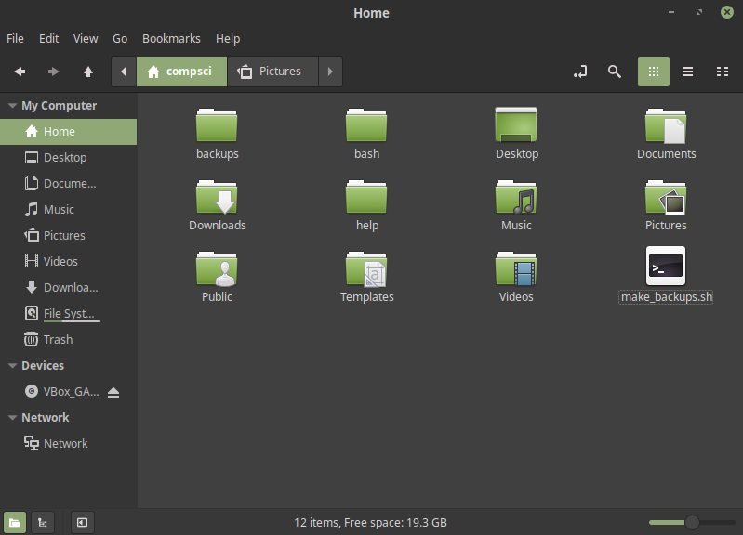Trying to make a tar backup of my bash folder so I can easily send out my programs to the cloud

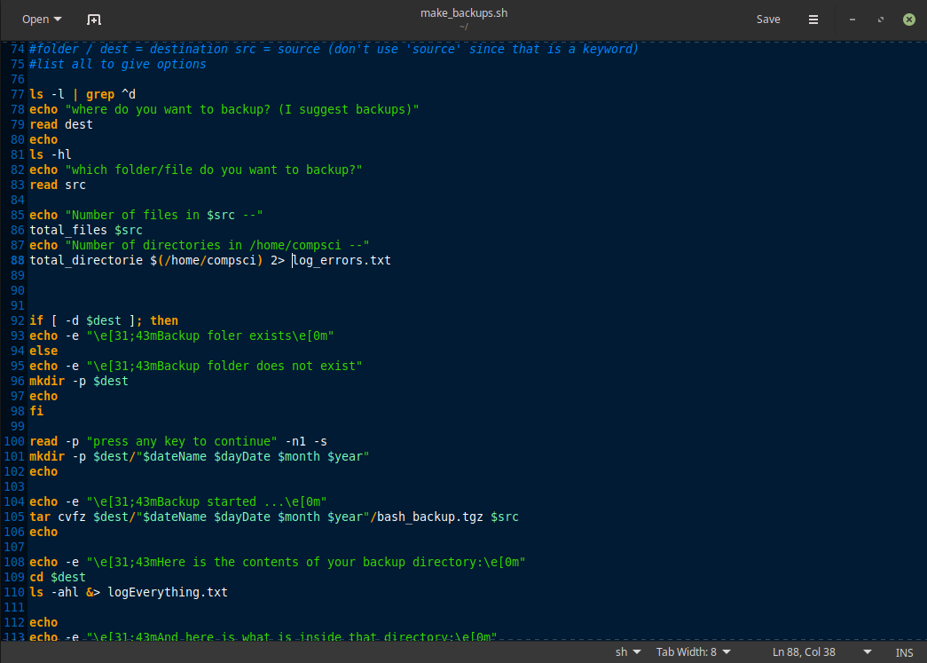

learned tar commands in order to make new folder to hold the backed up data

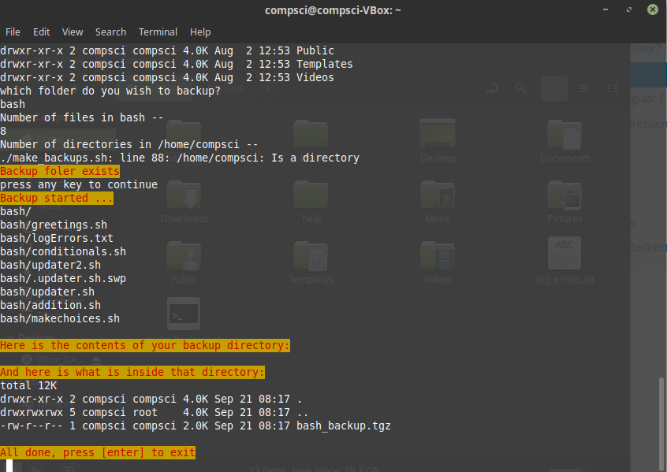

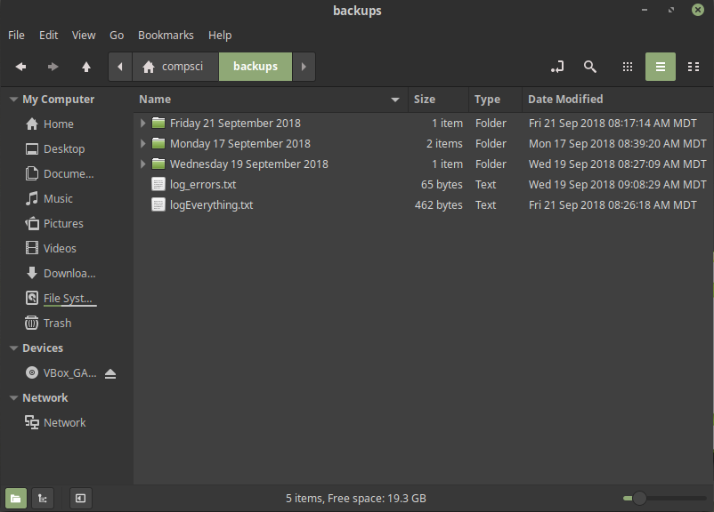

final result, also contains a log of errors that may have occurred in finding files or directories while trying to backup